CMS NAME: **Moodle++**

Based on: PHP/MySQL/HTML/JS

Created by: Vrajesh, Giaspur, Hyunh

*Each Class has a controller and model version for it. The model version does the querying and sorting, while the controller version just tells the model version to fire its functions.

**Views:**

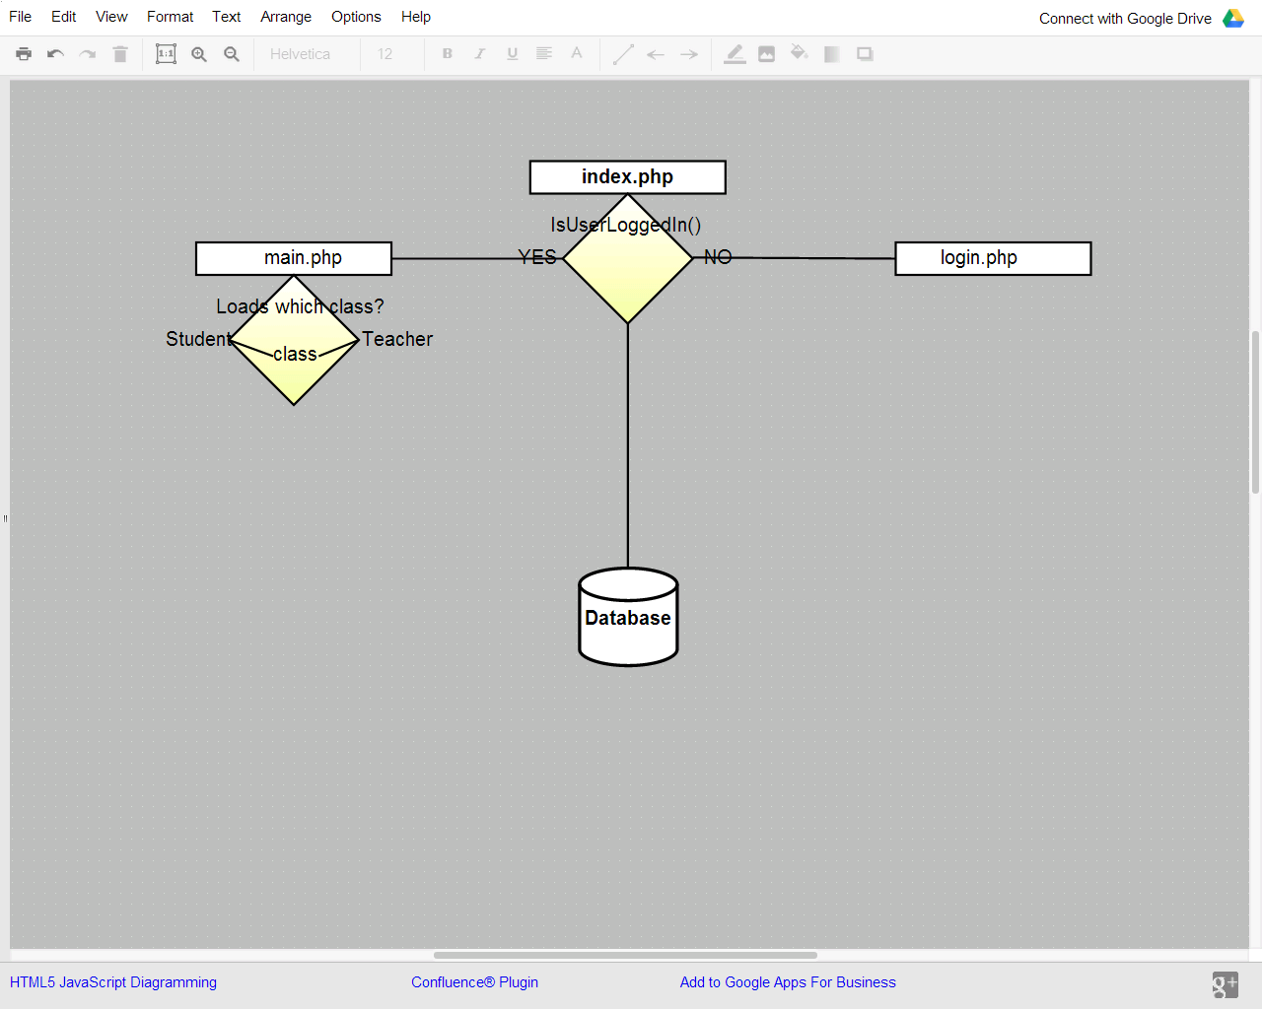

**Classes**

Login – Manages Login for Student and Teacher

Student – Manages Student: View Courses per Semester, view Assignments: grades, download files, ` take quizzes, post to chat

Teacher – Manages Teacher functions: Post Assignments, grades, files, Quizzes (also view them)

Forum – Manages Forum: Every Section and a Course is assigned a forum class. The participants in those ` forums are selected using (‘crn’) or only students who have registered for that course have ` access to this forum